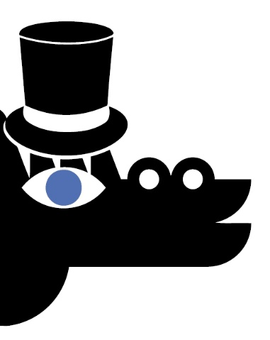
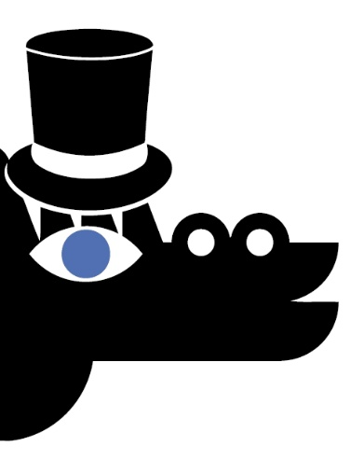

Delete the answers to the riddles in the quest, and use what remains to create a password!
Check if it is correct by logging into your account and adding the quest to your completed quests
on the Questy.org.pl portal.

THE KEYS PORTAL CRACOW TRAMWAY BAZYLISZEK

EFFECT: STYLE FESTIVE TREE STAR CULTURE

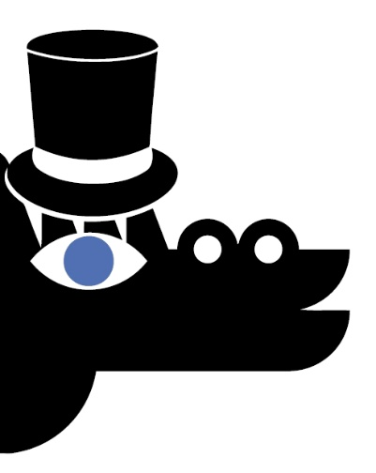
AND WELL AQUA CLOCK SZWAJCARKA

EIGHTEEN SCOOTER RESPECT HAWEŁKA

